ABOUT TAKE STOCK IN CHILDREN
Take Stock in Children was established in 1995 as a non-profit organization in Florida that provides a unique opportunity for low-income and at-risk students, many from minority families, to escape the cycle of poverty through education. We are active in over 800 schools throughout the State of Florida. Students are selected between the 6th and 9th grades, many from minority families, and must meet our low-income and at-risk guidelines.

THE PROGRAM
The Take Stock in Children of Sarasota scholarship program requires commitment from each student and their family. The program offers an incredible opportunity to students who are willing to participate fully and to meet program requirements consistently. Students in the Take Stock program are provided a caring volunteer Mentor, a College Success Coach, access to an array of workshops and hope for a better life.

For those who successfully complete the program, we guarantee a Florida Prepaid Scholarship. The scholarship provides an incentive to students who invest their "sweat equity" in improving grades and investing the time needed to be fully prepared for college. It also ensures our students complete college with minimum debt loads.

Our comprehensive services start in middle school, continue through high school and include the transition into college. The Take Stock team is committed to helping ensure that students graduate from high school with the knowledge and skills they need to complete their postsecondary education and to successfully enter the work force.

THE TSIC DIFFERENCE
We are unique among college readiness programs in the US. We don't rely on mentoring alone. Every student is assigned a professional College Success Coach who provides:
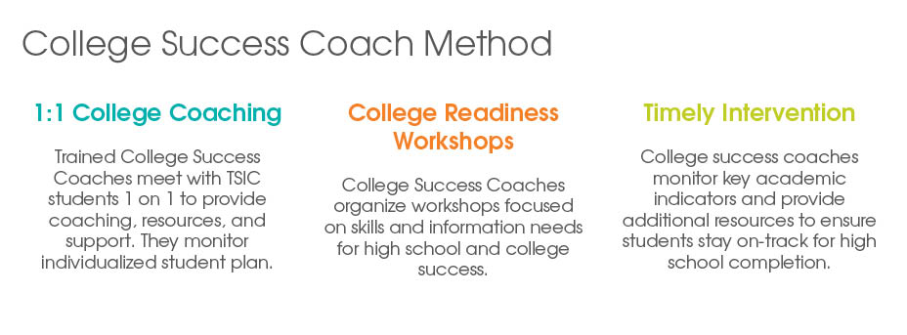
The Coaches also monitor leading indicators of student success to identify when a youth is getting off track. They rally the student's family, school, and mentor to intervene and ensure the student completes high school and enters college.

